Module 1: [Based on class & objects]

Problem Statement: Write a C++ program using class and objects to automate the banking process with following constraints:
- A new account can be created and an old account can be deleted
- An account holder can debit/credit money
- An account can’t be deleted if money exists in the account
- The program should be following menu operated
- The private data members of an account holder’s class are “Account No”, “Name”, “Age” and “Balance”.
- Design member methods for individual operation
- Produce appropriate message when required a.The template of the class is
class Account{
//private data members
//public methods
};

b.The menu is :
********** Main Menu ********
- Open New Account
- Close Old Account
- Deposit Money
- Withdraw Money
- Check Balance
- Exit
Enter Your option:(1-6):_
c. Few Snapshots:
- Deposit Money
Enter your option(1-6):3 <enter> Enter Account Number:12678 <enter> Enter Amount: 5000 <enter> Successfully deposited
Press any key go to main menu.....

Code:
#include <iostream>
using namespace std;
class Account
{
public:
string name;
int acn;
int balance;

Account()
{
}

void Open_account(string n, int a, int b)
{
name = n;
acn = a;
balance = b;
}
void Delete()
{
if (balance > 0)
cout << "Account can not be deleted. Withdraw your money first ;)" << endl;
else
{
name = " ";
acn = 0;
balance = 0;
cout << "Account deleted successfully" << endl;
}
}

void deposit(int b)
{
int old = balance;
balance = b;
old += balance;
balance = old;
}

void withdraw(int b)
{

int old = balance;
balance = b;

if (b > old)
cout << "Insufficient balance " << endl;
else
{
old -= b;
balance = old;
}
}
void Getdata()
{
cout << "Account number : " << acn << endl;
cout << "Name : " << name << endl;
cout << "balance : " << balance << " Taka " << endl;
cout << ".......................\n";
}
};
void print()
{
cout << "************* Main Menu ************* \n";
cout << "1. Open New Account " << endl;
cout << "2. Close Old Account" << endl;
cout << "3. Deposit money" << endl;
cout << "4. Withdraw money" << endl;
cout << "5. Check balance" << endl;
cout << "6. Exit" << endl;
cout << " Enter your option (1-6): " << endl;
}
int main()
{
int choice;
int index = 0;
string Name;
int Acn;
int Bal;
int temp_Acn, temp_balance;

Account b[10000];

while (1)
{
print();
cin >> choice;

switch (choice)
{
case 1:
cout << "Enter your Name: ";
cin >> Name;

cout << "Enter your balance: ";
cin >> Bal;
Acn = 1000 + index + 1;

b[Acn].Open_account(Name, Acn, Bal);
b[Acn].Getdata();
index++;
break;
case 3:
cout << "Enter your account number: ";
cin >> temp_Acn;
if (temp_Acn < (index - 1) && temp_Acn > 1000)
{
cout << "Enter your depost balance: ";
cin >> temp_balance;
b[temp_Acn].deposit(temp_balance);
b[temp_Acn].Getdata();
cout << "Success" << endl;
}
else
cout << "Invalid account" << endl;

break;
case 4:
cout << "Enter your account number: ";
cin >> temp_Acn;
if (temp_Acn < (index - 1) && temp_Acn > 1000)
{
cout << "Enter your withdrwal balance: ";
cin >> temp_balance;
b[temp_Acn].withdraw(temp_balance);
b[temp_Acn].Getdata();
cout << "Sucess" << endl;
}
else
cout << "Invalid account\n";

break;
case 2:
cout << "Enter your account number: ";
cin >> temp_Acn;
if (temp_Acn < (index - 1) && temp_Acn > 1000)
{
b[temp_Acn].Delete();
}
else
cout << "Invalid account" << endl;

break;
case 5:
cout << "Enter your account number: ";
cin >> temp_Acn;
if (temp_Acn < (index - 1) && temp_Acn > 1000)
{
cout << "Your current balance: " << b[temp_Acn].balance << " Taka" << endl;
}
else
cout << "Invalid account" << endl;

break;
case 6:
cout << "Thank you" << endl;
return 0;
break;

default:
break;
}
}
}

Output Snippet

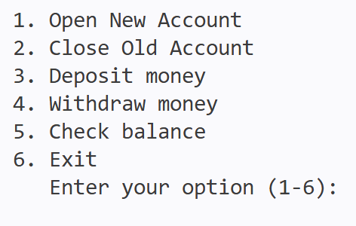 |  | 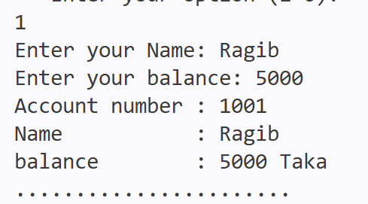

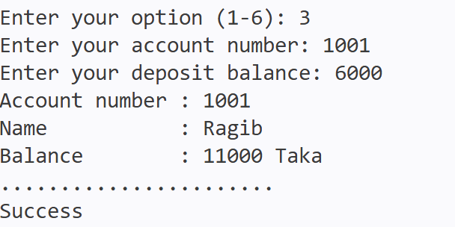 |  | 